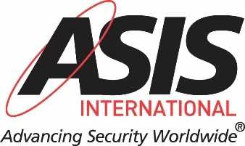

2024 GLOBAL AND REGIONAL GOVERNANCE FAQS

The following FAQs are intended to answer questions members may have regarding ASIS International’s global and regional governance efforts in 2024. These efforts are related to the selection of the regional nominating committees and the officers and directors of the Global and regional Boards.

WHAT IS THE ASIS GOVERNANCE STRUCTURE?

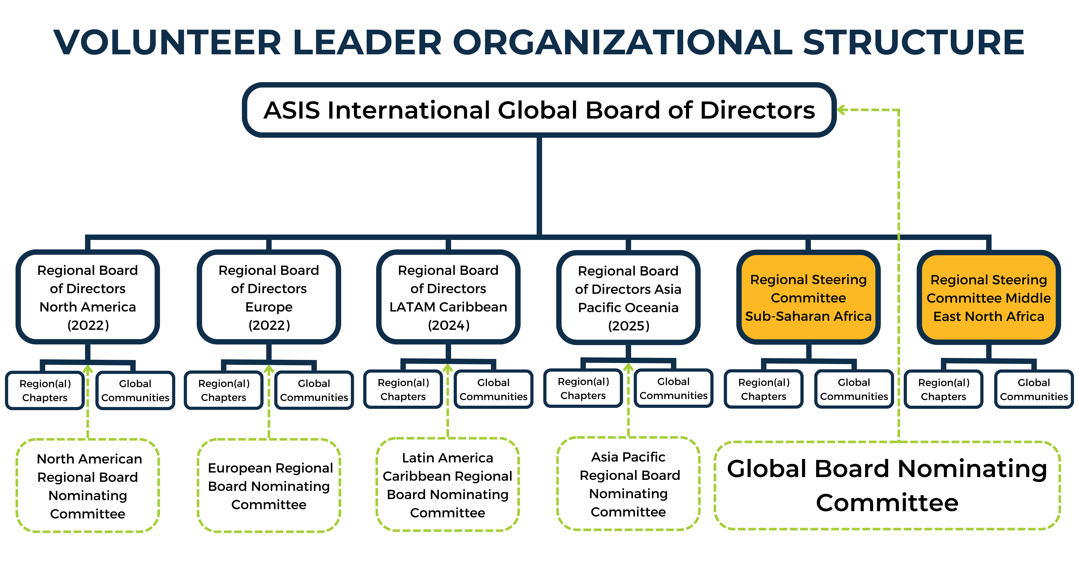
WHAT GLOBAL GOVERNANCE ACTIVITIES WILL BE TAKEN IN 2024?

In 2024, ASIS will be seeking candidates for the Asia Pacific Regional Board Nominating Committee, European Regional Board Nominating Committee, Latin America Caribbean Regional Board Nominating Committee, and North American Regional Board Nominating Committee. There are no open positions for the Global Board Nominating Committee in 2024.

After that process, we will be seeking Director candidates for the Global Board, Asia Pacific Regional Board, European Regional Board, Latin America Caribbean Regional Board and North American Regional Board for 2025.

WHAT ARE THE ROLES, RESPONSIBILITIES, COMPETENCIES AND ELIGIBILITY REQUIREMENTS FOR THOSE THAT SERVE ON THE REGIONAL BOARD NOMINATING COMMITTEES?

Nominating Committee Role and Responsibilities

In addition to selecting its own members, Nominating Committees identify and select officer and director candidates to serve on ASIS Boards who meet the desired competencies and characteristics identified for the overall composition of the Board. They will ensure that the selection process is properly implemented as prescribed in the association’s policies.

In many respects, the nominating committees are the most important committees at ASIS; these committees are responsible for the selection of the leaders of the organization at the global and regional level.

Nominating Committee Competencies

Members considering a role on an ASIS nominating committee must have a passion for the organization to ensure the leaders selected will do their duty to guide the organization to meet the mission of the organization and the global security profession. Specifically, candidate should possess the following skills and traits:

- Demonstrated ability and desire to listen to others
- Awareness of ASIS strategic goals, structure, and mission
- Demonstrated experience in interviewing, making hiring decisions, supervisory and management experience
- Capacity to keep private confidential discussions and candidate identities
- Broad and deep knowledge of current and emerging industry and association leaders
- Ability to speak and write in English
Nominating Committee Eligibility Requirements

1) Ideal candidates for a Nominating Committee must have been a member of ASIS and have served as a volunteer in a leadership role (Chapter Chair, Chapter Vice Chair, Community Chair, Community Vice Chair, global or regional board committee member, member of the PSB, PCB, Foundation BOT, CSO Center Board, etc.) for no less than 5 years.
2) Members may only apply for the nominating committee for the region in which the chapter they are assigned is located.
3) If you do not currently meet this membership or volunteer leader criteria, you should consider other ways to volunteer your time with the organization. Please visit ASIS Volunteer Portal on Connects for more information about other volunteer opportunities and how to get more involved.

In order to be considered for a Board Nominating Committee, you must be available:
1) To review Board and officer candidate interest forms and evaluate them online during the months of September, October, and November.
2) To meet via Zoom to select the slate of candidates in October and/or November.
Please note that to ensure complete transparency and no one to have an “inside track” for an ASIS Regional Board position, any successful candidate for the Regional Board Nominating Committees will not be eligible to apply to serve on the corresponding Regional Board for a one (1) year after completing service on a Regional Board Nominating Committee.
Should you have any questions, please contact Gigi Portlock, Foundation and Governance Program Manager, gigi.portlock@asisonline.org or Susan Mosedale, Chief Global Member Engagement Officer, susan.mosedale@asisonline.org.

HOW WILL THE 2024 REGIONAL BOARD NOMINATING COMMITTEE MEMBERS BE SELECTED?

Candidate interest forms for the Asia Pacific Regional Board Nominating Committee, European Regional Board Nominating Committee, Latin America Caribbean Regional Board Nominating Committee, and North American Regional Board Nominating Committee will open on 1 May and close on 31 May. Members may apply to only one (1) committee through this process. Members may only apply for the nominating committee for the region to which they are assigned by the address in their membership profile. You will be required to upload a headshot and submit a brief video regarding your candidacy. Your information will be held in confidence by ASIS International headquarters staff and volunteer leaders involved in the selection process.
The candidate interest forms will be reviewed and evaluated by the sitting Nominating Committee members. An uncontested slate of candidates will then be presented to the Global Board of Directors for ratification. Selected candidates will be notified in late August and work will commence in Q4 2024.

NOTE: Candidates must be members in good standing and have been a member for more than 5 years. Candidates may only apply for one (1) Nominating Committee position.

Asia Pacific Regional Board Nominating Committee
Two (2) positions will be selected through this process for either a 1 year, 2 year, or 3 year term. It is anticipated that this committee will meet via Zoom several times in Q4 of 2024. THE GLOBAL BOARD WILL BE APPOINTING THE CHAIR AND 3 PERSONS TO SERVE ON THIS COMMITTEE. THESE APPOINTMENTS WILL BE ANNOUNCED MID-MAY.

European Regional Board Nominating Committee
Two (2) positions will to be selected through this process for a three (3) year term. It is anticipated that this committee will meet via Zoom several times in Q4 of 2024.

You will join the following members on the Nominating Committee:
Eric Davoine, CPP, Chair
Jean-Fernand Perenne, CPP, Member
Berndt Rif, CPP, PCI, Member
Edwin van de Weerd, APP, Member
Peter J. O’Neil, FASAE, CAE, Ex-officio, Nonvoting Member
Andy Williams, CPP, Vice Chair, ERBOD – Liaison to the Committee

Latin America Regional Board Nominating Committee
Three (3) positions will be selected through this process for either a 1 year, 2 year, or 3 year term. It is anticipated that this committee will meet via Zoom several times in Q4 of 2024.

You will join the following members on the Nominating Committee:
Gerardo de Lago-Acosta, CPP, Chair
Andrea Del Herrera, CPP, Member
Jose Barone, PSP, PCI, Member
Peter J. O’Neil, FASAE, CAE, Ex-officio, Nonvoting Member
Marco Vega, CPP, Vice Chair, LACRB – Liaison to the Committee

North American Regional Board Nominating Committee
Two (2) positions will be selected through this process for a three (3) year term. It is anticipated that this committee will meet via Zoom several times in Q4 of 2024.

You will join the following members on the Nominating Committee:
Jason Caissie, CPP, PCI, PSP, Chair
Mark Gaudette, CPP, Member
Ter Govang, CPP, Member
Amy Poole, Member
Peter J. O’Neil, FASAE, CAE, Ex-officio, Nonvoting Member
Craig Russell, CPP, Vice Chair, NARBOD – Liaison to the Committee

WHAT ARE THE ROLES, RESPONSIBILITIES, COMPETENCIES, AND ELIGIBILITY REQUIREMENTS FOR THOSE SEEKING TO SERVE ON THE GLOBAL AND REGIONAL BOARDS?

Global and Regional Board Role and Responsibilities

Global Board of Directors - Provide strategic guidance, high-level oversight, and resource allocation for global direction of the organization. This is the ultimate fiduciary body of the organization, and its primary function is to determine global strategy and the resources necessary to implement that strategy.

Regional Boards of Directors - The regional boards, reporting to and working in concert with the Global Board of Directors, determines the business plan that meets the needs of members in a specific region in alignment with the global strategic plan that is locally, regionally, and culturally relevant. Regional boards carry out strategy, policy, and standard operating procedures in their respective regions.

Global and Regional Board Competencies

- Emotional Intelligence - The ability to recognize, interpret, and regulate your own emotions, and understand those of other people that allow for better personal well-being and interpersonal relationships.
- Management experience - Understanding of key management processes and functions, including resource allocation, fiscal management, organizational structure, etc. Must be able to maintain objectivity while evaluating ASIS strategic objectives. A range from seasoned careerists to early careerists will be considered.
- Knowledge of ASIS programming - Knowledge of and participation in the organization including volunteer leadership, certifications, and attendance/participation in ASIS offerings.
- Knowledge of security profession - Demonstrated security industry knowledge in various sectors.
- Marketing/brand knowledge - Demonstrated knowledge of or appreciation for brand and its protection. The board members should possess the capacity to think strategically about the organization’s brand position globally.
- Effective communication – Ability to exchange ideas, thoughts, opinions, knowledge, and data so that the message is received and understood with clarity and purpose.
- Strategy development - Solid understanding of the strategic planning process including strategy development and evaluation. Acumen in organizational performance drivers is desired.
- Visionary thinker - Demonstration of forward thinking, setting direction for an organization.
- Team orientation - Appreciation for a collaborative environment, thus being able to foster and maintain partnership and collaborate with key internal and external stakeholders. Must have proven record of working collaboratively with executives as well as early careerists.
- Leadership skills - Effective communication skills, capacity to influence decision makers, demonstration of emotional intelligence, consultative approach to problem solving, etc. Demonstrated leadership roles internal and external to ASIS. Understand the concept of servant leader.
- Global/regional outreach - Understand the external forces in which the organization operates, by showing an appreciation of the competitive environment and how it applies globally, regionally, and/or locally. Demonstrate an understanding of global/regional risk and opportunity.
- Digital transformation - Demonstrate keen understanding of the opportunities and risks around the digital landscape (including skills requirements in the future) and its continuing evolution.
- Cultural intelligence - Understand and appreciate the importance and advantages of diversity and inclusiveness from different perspectives, including from a cultural perspective. Must be a contributor of intellectual and experiential diversity, plus demonstrate corporate diplomacy.
- Proficiency in English - Ability to read, speak, and write fluently in the English language.

Global and Regional Boards Eligibility Requirements

- Ideal candidates for a Global or Regional Board must have been a member of ASIS and have served as a volunteer in a leadership role (Chapter Chair, Chapter Vice Chair, Community Chair, Community Vice Chair, global or regional board committee member, member of the PSB, PCB, Foundation BOT, CSO Center Board, etc.) for no less than 5 years.
- If you do not currently meet this membership or volunteer leader criteria, but want to give of your time and talent to ASIS in other ways, please visit the ASIS Volunteer Portal on Connects for more information about other volunteer opportunities and how to get more involved.
- If you do meet this membership and volunteer leader criteria, please consider whether that service has prepared you to be part of a globally focused organization that sets strategy and policy for regions to use as guidance through a distributed authority governance system.
- If you are not prepared to serve one, three-year term if selected, you should not apply for this opportunity. Further, note that while a sitting Director may apply for a second, three-year term, such a selection is not guaranteed.
- You may not apply to a Global or Regional Board if you have a volunteer leader role that does not expire before the term on the Board begins. In addition, you may not apply to the Global Board if you intend to apply to serve on a Regional Board of Directors, PSB, PCB, CSO Center Board of Foundation Board of Trustees.
- If you have a term on a board or committee of a competing organization to ASIS International, and that term will not be over by the time the term with the Global or Regional Board begins, please do not apply.
- ASIS is committed to fostering an environment of diversity, equity, and inclusion. We provide a collaborative work environment where we strive to create a culture of belonging for all our members and volunteer leaders. As we seek candidates to serve on the Global and Regional Boards, we highly encourage applicants from diverse backgrounds to apply. ASIS is built on the fundamental premise that diversity and inclusion of all, regardless of gender identity, race, sexual orientation, ethnic origin, national origin, religion, disability, age, and/or professional practice is foundational to our global success.
- All selected candidates will be subject to a criminal background check.

In order to be considered for the Global or Regional Boards of Directors, candidates must be available to attend:
- Virtual board orientation meeting in January 2025
- Annual Volunteer Leadership Exchange (virtual) - January 2025
- ASIS Europe – March 2025 (European Regional Board only)
- One virtual Board meeting every other month on average; possible in-person meetings twice per year including during GSX 2025
- GSX 2025 – September 2025

HOW WILL THE 2023 GLOBAL AND REGIONAL BOARD NOMINATING COMMITTEE MEMBERS BE SELECTED?

Candidate interest forms for the Global Board, Asia Pacific Regional Board, European Regional Board, Latin American Caribbean Regional and North American Regional Board Nominating Committees will open on 15 August and close on 30 September. Members may apply to only one (1) Board through this process. Other than the Global Board, members may only apply for the Board for the region to which they are assigned by the address in their membership profile. You will be required to upload a headshot and submit a brief video regarding your candidacy. Your information will be held in confidence by ASIS International headquarters staff and volunteer leaders involved in the selection process.

An uncontested slate of candidates will then be presented to the Global Board of Directors for ratification. Selected candidates will be notified in late November.

NOTE: Candidates must be members in good standing and have been a member for more than 5 years. Candidates may only apply for one (1) Board position.

Global Board of Directors
- One (1) director position will be selected for a 3-year term for the Global Board of Directors.
- One (1) officer position will be selected for a 1-year term for Secretary/Treasurer of the Global Board of Directors. The officer position must be chosen from sitting director members.
- One (1) officer position will be selected for a 1-year term for President-elect of the Global Board of Directors. The officer position must be chosen from sitting director members.

Asia Pacific Regional Board of Directors
- Six (6) director positions will be selected for a 1 year, 2-year or -3-year term for the Asia Pacific Regional Board of Directors. THE GLOBAL BOARD WILL BE APPOINTING THE CHAIR, VICE CHAIR, SECRETARY/TREASURER AND THREE PERSONS TO SERVE ON THE REGIONAL BOARD. THESE APPOINTMENTS WILL BE ANNOUNCED MID-MAY.

European Regional Board of Directors
- Four (4) director positions will be selected for a 3-year term for the European Regional Board of Directors.
- One (1) officer position will be selected for a 2year term for Secretary/Treasurer of the European Regional Board of Directors. The officer position must be chosen from sitting director members.
- One (1) officer position will be selected for a 2-year term for Vice Chair of the European Regional Board of Directors. The officer position must be chosen from sitting director members.

Latin America Regional Board of Directors
- Two (2) director positions will be selected for a 3-year term for the European Regional Board of Directors.

North American Regional Board of Directors
- Three (3) director positions will be selected for a 3-year term for the North American Regional Board of Directors.

WHERE CAN I FIND MORE INFORMATION?

In addition to these FAQs, you get more information more information at https://www.asisonline.org/get-involved/global-and-regional-governance/ and/or by emailing the ASIS at BoardApplicationQuestions@asisonline.org.

